TMA01  [TM354-14J](https://learn2.open.ac.uk/course/view.php?id=202632" \o "Software engineering) Stuart Mathews (Y6718837)

Question 1

1. Generally speaking, documentation is important to describe how or why a system works in the way it does, and also most often it represents what the requirements are, particularly that the system needs to deliver. But within the context presented, this is particularly useful when you are outsourcing or future audiences who need to become familiar with the system. Documentation also leads to traceability in the sense that it documents decisions and choices that were made when designing the system.
2. To document why the software exists, what the problems it strives to solve. Convey the content of the idea you are trying to communicate, not any particular form of that content, so that the content, not any particular form of it, is made clear. Arguably, another principle is not to document something if you don’t need to.

b)

Individuals and interactions over processes and tools

Typically with scrum, people are involved in most of the planning, execution, and feedback during development. Each isn’t limited to any particular role, and as such they will have to extend some of their skills to cope in this regard and thus it’s important that they communicate effectively and work well so people can feedback and help each other. This allows the work done to be a representation of collaborative discussions which determine the most effective way the team can work, instead of using a predefined process or tools that don’t take into consideration the team’s evolution of ideas, skills and strengths etc…

Working software over comprehensive documentation

Producing working software, particularly in small iterative steps where iterations produce thin ‘slivers’ of the most important requirements/ideas as determined by the team for each ‘sprint’. This allows for adaption to changes in the teams thinking or requirements in general but still leaves working, tested and integrated software at each step. This can be built upon or changed making the foundation of the functionality firm yet malleable. Documentation would need to be changed very often to cope with this approach, making it time consuming and impractical and unproductive.

Customer collaboration over contract negotiation

Determining what is valuable and thus what are the most important ideas and problems that the team needs to focus on is key. This allows prioritisation early on and delivering the more important functionality first. Customers also provide a valuable feedback mechanism before it’s a finished product which is more useful during iterations, as it drives the change of implemented work, than afterwards when it less easy for the system to ‘change’ and ‘adapt’. Contract negotiation, tries to inhibit change and thus reduce the flexibility of a software system as it is constructed, thus its not indicative of how agile tries to iterate continually and thus make the decisions early on when its most effective to the production of the software.

Responding to change over following a plan.

Scrum/agile, being able to produce small, incremental working, testable and verifiable changes early on in the development lifecycle allows for creating the most effective version of the software early on. This is partially due to constant feedback, assessment and team-lead decisions at the point of changes that occur. This allows the design to change easily and deliver on the meeting the new change. A plan represents something that is not expecting to change or adapt to unexpected events so is contrary to scrum/agile methods.

[396]

c) Models are a representation of an idea or concept which reveals a certain perspective which allows people in the development process to use them to simulate ideas, collaborate and discuss them. They allow people to see the relationships between ideas, and abstract only certain important ideas/concepts as to not over complicate it with unnecessary detail. It also allows one to interpret the behaviour and integration of concepts and ideas.

Question 2

1. Provide users with online functionality to interact with the Walton store’s services. This includes shopping activities like browsing, buying, returning and returning products. Ultimately It enables Walton with an interface with the customers so that it can provide a next-day collection service for customers.
2. This would be anyone with a vested interest in the system. Probably most notable the Walton management. Also, people using the system who might perceive value in it such as as potential shoppers (member of the public), registered users themselves, Administrators and Senior administrators who will administer the system. The depot assistants. Possibly even the Walton warehouse service staff/system.
3. User includes the Administrators and the senior administrators, member of the public, register shoppers and depot assistants. This could also include other external systems such as the Walton warehouse system(WSS).
4. WSS – Walton Shopping Service, WID – Walton Identification number.
5. To build a website that interacts with shoppers and Walton staff members to provide online production functionality. This is confined to online product online services (browsing, reviewing, buying, returning). This includes interaction with Walton depot staff but excludes external systems such the Walton warehouse service.
6. The system must allow the user to browse an online catalogue of products and view products. The system must allow the user to review products. The system must provide a means to track their order and remove and add items to it.
7. The system should be responsive(Non-functional) – particularly when browsing existing products in the catalogue (Functional). This is part of the ‘Performance requirements’ . Fit criterion: It takes no longer than 4 seconds for the details of a product to come up and be viewable.
8. Risks: An example of a risk to WSS is increased demand/use on the website such that performance requirements are compromised such as 5-10 second product loading times.

Question 3

a)

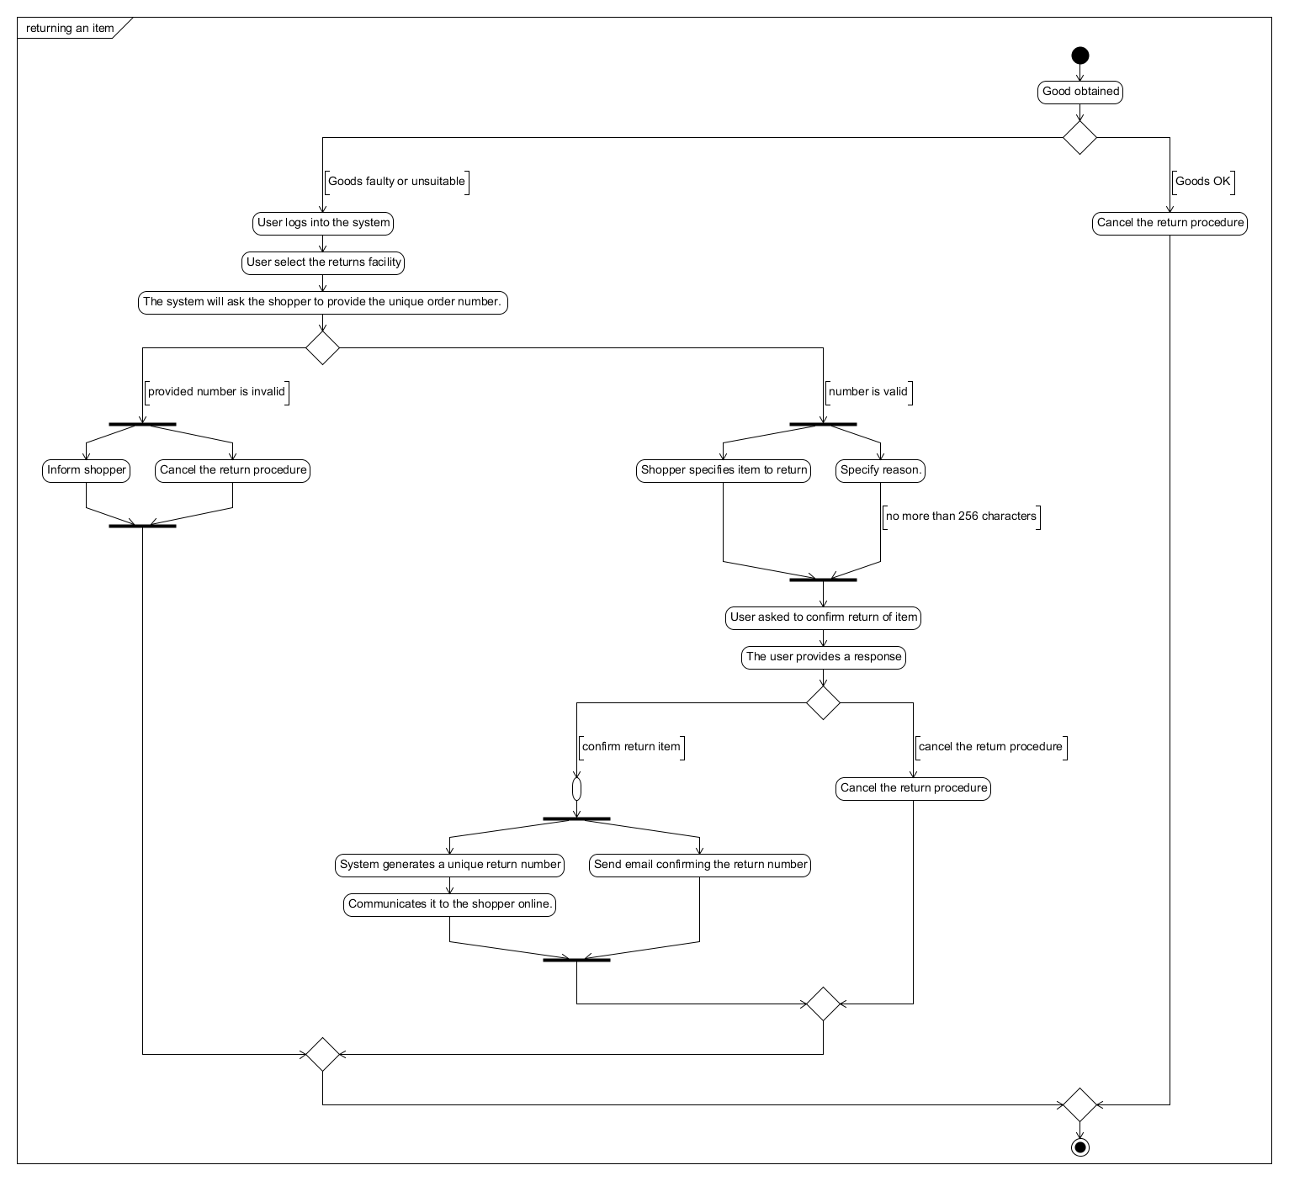

Figure My initial model

b)

My comments to “Annamaria Toth”

I wonder if it is superfluous to add extra detail about failed login/authentication attempts because the concepts is you either can log on or you can't and the appropriate steps are taken after each one... That said, you're not wrong, if just wonder if its making it too complex. That said, I like that yours is in colour. I wonder if the provide navigation menu step is also unnessesary to represent - its factually correct but it hides the true purpose of the essence of the logic you're trying to portray. I do like the idea of 'no more items' to return because you're right, there could be multiple items. I like it

My comments to “Stuar t James”

I think you went too far in your diagram - i don't think the interaction with the depot assistant was needed.  
  
i think after 'validate order number', that branch should be under WSS as it takes action on the result of that moving forward such to inform the user etc..  
  
Also i like the added idea of specifying that items are displayed to the user as a step but is is necessary because it might cloud the logic of what the diagram essentially trying to portray - essential steps but you might argue that this is an essential step...in which case perhaps you are right.   
  
Generating the return number and sending the email should be parallel activities.  
  
Strictly speaking you should only have one END step, you have multiple which represent the same end step, i understand that though...  
  
Also i think you went too far - you dont need to represent the refunding of payment to the customer..   
  
That said, I like your drawing software and how you put it all together - it looks clear and clean. Please consider my comments as feedback and constructive - its always easier for someone else to! Take care

c.

My updated model:

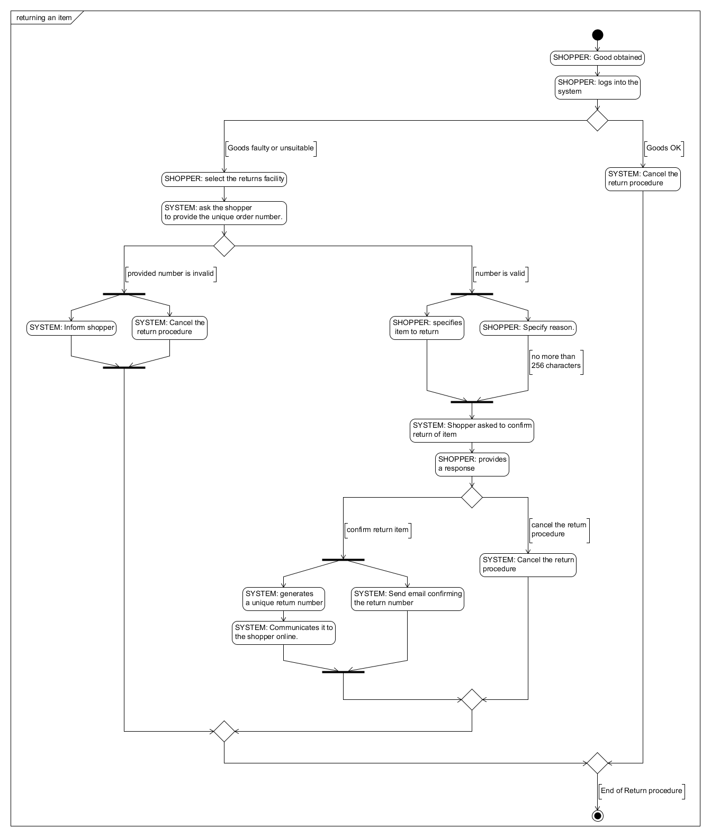

Figure : My updated model:

My comments on improving my model:

The model now introduces a means to identify the actors involved and indicate who initiated the steps. It was suggested that I might introduce swim lanes to achieve this; however my software didn’t have this functionality. So I’ve compromised and achieved this by prefixing the actor title to the step. It was said the diagram wasn’t easy to follow and I think this is because of the long descriptions, so I’ve shortened them. Also, It was suggested that the cancel procedure is only invoke after a successful login had occurred, so I’ve moved the login stage earlier in the process.

[100]

Question 4

|  |  |  |
| --- | --- | --- |
| Actor | Chosen role name | Interaction with other actors |
| Unregistered user | [guest], | Could possible send a query to WSS which the Administrator might get. |
| Registered user | [member] | Ultimately give return number to depot assistant in the case of returns. Could post reviews which other users can see |
| Administrator | [admin] | Would change prices of items which the registered and unregistered users would see. This is the same with adding a category and removing a product. |
| Senior administrator | [super admin] | Would interact with any user by adding a new depot and information about it to the system. |
| Depot assistant | [depot team] | Would interface with the customer when returning a item. |
| Walton warehouse service | [warehousing] | Would interface with the registered user, indirectly by providing a return number(and verifying it ). It would also interact with the depot assistant when the assistant will enter the return number into WSS and the warehouse system will get consulted on the item that need returning |

b.

|  |  |
| --- | --- |
| Use case identifier | Use case description |
| PUBLIC_UC01 | Public can browse products |
| PUBLIC_UC02 | Public can see descriptions of products |
| PUBLIC_UC03 | Public can read product reviews |
| PUBLIC_UC04 | Public can see the average rating in relation to other members’ |
| MEMBER_UC01 | Shopper can place an order. |
| MEMBER_UC02 | Shopper can add items to a shopping cart |
| MEMBER_UC03 | Shopper can modify qualities of items at anytime |
| MEMBER_UC04 | Shopper can select an appropriate depot for collection |
| WAREHOUSE_UC_01 | Warehouse system can generate a unique number |
| STAFF_UC01 | The staff can collect information about customer product on upon customer collection |
| MEMBER_UC05 | Shopper can return an item if it is faulty |
| MEMBER_UC06 | Shopper can tell the system what product they are returning. |
| MEMBER_UC07 | Shopper can return the faulty item to the same depot that the user bought the item from |
| STAFF_UC02 | Assistant is able to record the return number into the system. |
| MEMBER_UC08 | Shopper can view the orders that have placed before. |
| ADMIN_UC01 | Administrators can add a category |
| ADMIN_UC02 | Administrators can add a product |
| ADMIN_UC03 | Administrators can change the price of a product |

c.

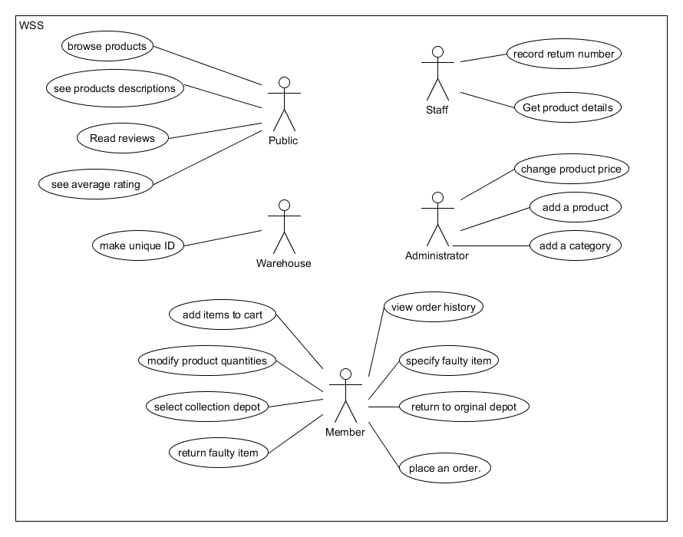

d.

Firstly, I believe that it is necessary to implement the storage and retrieval of the business information such products, categories, depots, reviews. This is to establish the entities and business objects that will represent the majority of the interaction with the system and as such these should be defined first.

Next, the basic user website interface to interact with the above entities in a CRUD(Create/Read/Update/Delete) fashion should be implemented. This is particularly important so that planned processes involving these entities can be implemented and tested early on and this would represent a large majority of the core system.

Once the entities are represented on the website in a basic fashion, the various workflows involving them should be drafted included the technologies and methodologies that are to be used such as the ordering, reviewing and return/refunding process. This will include thinking about how to implement these such as a shopping cart .

Seeing as the processes needed in the website are defined, it would be a good idea to start implementing them starting with the ordering process, utilising the shopping shoping cart logic as well as the return policy workflow should be implemented in the website.

The security and user authentication should be next as a means to protect all of securing the above.

e. I think a important aspect would be the user interaction process with the website, from logon to navigation to submitting orders, viewing products and returning items. This can be done with a series of activity diagrams which detail the interaction the user will have with the website at various steps and stages of the process being modelled

Question 5

a)

SFR1: UC10, Step1

Description: The system shall be able to make a request to add a product.

Fir criterion: The add product page is displayed to the administrator

SFR2: UC10, Step2

Description: The system shall be able to allow the administrator to select a category

Fir criterion: The category selected page is displayed to the administrator

SFR3: UC10, Step2.a.1

Description: The system shall provide the ability to specify a category name

Fir criterion: A new category button is provided on the page.

SFR4: UC10, Step2.a.2

Description: The system shall be able to request a category name

Fir criterion: A new category page is displayed

SFR5: UC10, Step2.a.3

Description: The system shall be able to allow the administrator to enter a category name

Fir criterion: A category name field is provided on form.

SFR6: UC10, Step2.a.4

Description: The system shall be able to save the provided category

Fir criterion: The category is displayed in the categories page.

SFR7: UC10, Step3

Description: The system shall be able to request a name, picture,description and price of a product.

Fir criterion: A new product page with name, picture, description and price fields is shown to the administrator.

SFR8: UC10, Step4

Description: The system shall be able to allow the administrator to provide a name, picture, description and price of the product

Fir criterion: A new product page with name, picture, description and price fields is shown to the administrator.

SFR9: UC10, Step5

Description: The system shall be able to request a identification number for the product

Fir criterion: A unique identification number field is presented to the administrator

SFR10: UC10, Step6

Description: The system shall be able to capture the identification number

Fir criterion: The identification number field is mandatory in the form.

SFR11: UC10, Step6.a.1

Description: no identification number provided

Fir criterion: the form cannot be submitted, the field text is changed to red to inform the user

SFR12: UC10, Step6.a.2

Description: The system shall be able to generate a unique number

Fir criterion: A unique number is shown to the user on submission success page.

SFR13: UC10, Step6.a.3

Description: The system shall be able to issue the identification number to the user

Fir criterion: An email is sent to the user with the identification number.

SFR14: UC10, Step7

Description: The system shall be able to add a product.

Fir criterion: The product is listed in the ‘products’ page.

SFR15: UC10, Step8

Description:

Fir criterion:

SFR16: UCx, Stepx

Description:

Fir criterion:

SFR17: UCx, Stepx

Description:

Fir criterion:

b)

Firstly I would ensure that each requirement is testable and attach a fit criterion to each requirement. I would review the requirements and associated fit criterion with the stakeholders to ensure they are correct.